- This time we are going to allow users enter score for match before proceeding settlement. This is to assure that half time/ full time scores are recorded accordingly and can be used to settle BETDAQ Over/Under tickets in abandoned/ postponed match.
Example: the match between Blackpool and Hull City is abandoned/ postponed at 60th minute. This match has BETDAQ tickets and among of those are OVER/ UNDER ones.
Half time score is 1-1. Let’s say in this case Score Team needs to refund FT.

- Check “Settle determined tickets (Over/Under)
- Then the area for inputting scores along with the yellow note will be displayed.
- Input scores (in this example, input final score)
- Click Refund FT button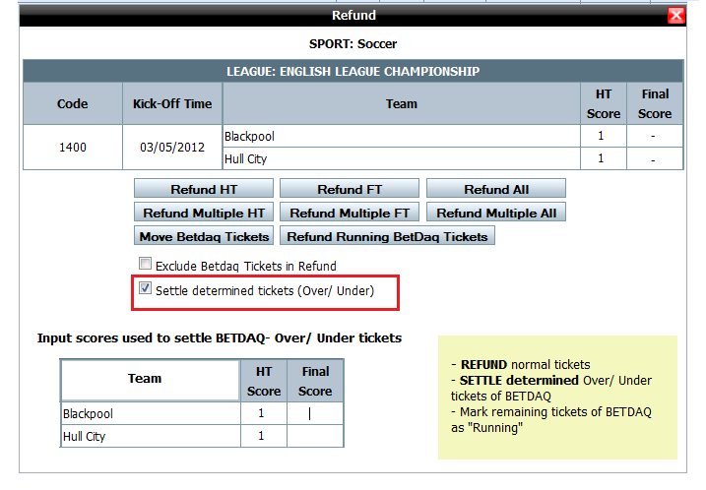
- A popup will appear to let user check again the score entered
- It is required to blur the surrounded area to draw user’s attention to the score window.

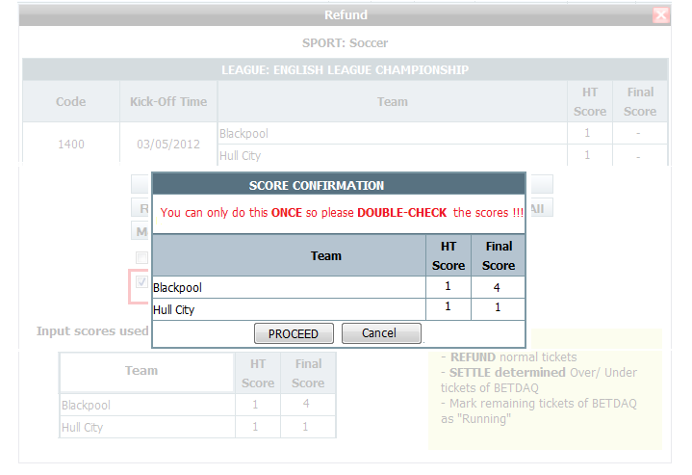
The final score entered will be written into log and this helps maintain the score when we do refund. Meanwhile, score shown in all sites will still be 0.
User clicks Re-input score to input score again
User clicks PROCEED button to confirm the entered final score to be correct and executes these things:

- Normal tickets (not BETDAQ tickets) will be refunded
- Determined tickets (status WON/ LOSE clearly determined) of O/U BETDAQ will be settled
- BETDAQ tickets which still cannot be determined exact status will be marked as “Running” (result may be different if the match resumes)

After we do Refund FT with normal tickets and settle determined tickets then checkbox “Settle determined tickets (Over/Under)” will be removed as illustrated.
After that, if the match will not be resumed, relevant department will refund remaining BETDAQ tickets.


